Let Red Gold Tomatoes from Europe Help Make Your Holiday Season Joyful

Season's Greetings to all!

This holiday season we can all use a little extra goodness, and since Red Gold Tomatoes from Europe are jam-packed with goodness, adding them to our own festivities—whether in person or virtual-- is a wonderful idea! Cooking with these delicious tomatoes gives a unique twist on everything, and especially for two of our favourite festive treats: Cocktails and Pies!

Red Gold Tomatoes from Europe are rich, sweet, juicy, and grown in sun-kissed soil. Two of our chefs have created special recipes for you to enjoy: a luscious tomato cocktail and a delicious apple pie with tomato jam!

These extraordinary canned tomatoes, Red Gold Tomatoes from Europe, add warmth and vitality to the winter season's festivities, in your kitchen, on your table, and in your glass!

Bloody Massimo

Chef Massimo Riccioli
Time: 25 minutes
Difficulty: Easy
Serves: 4

Ingredients:
2 slices stale country bread, cut into 4 croutons
olive oil for brushing
500 g pureed tomatoes (Passata)
1 teaspoon balsamic vinegar
salt and white pepper to taste
2 tablespoons vodka
1 or 2 celery stalks, cut into sticks
400 g fresh mozzarella
1 bunch fresh basil leaves

Method:
Brush the bread with olive oil, then bake in a hot oven or under the grill until crisp and golden brown, a few minutes on each side, then set aside.
Cook 400 g of the pureed tomatoes with two pinches of salt for about 5 minutes on a low heat. Then, add the remaining uncooked pureed tomatoes and balsamic vinegar. Mix carefully, adjust for salt and add the vodka.

Blend the mozzarella with about 2/3 leaves of basil and a pinch of white pepper until it forms a smooth cream; place a layer in the bottom of four wide-bottomed martini glasses.
Full the glasses with the tomato mixture, and garnish with a stick of celery, a toasted bread crouton, and a few leaves of the reserved basil.
Mini apple pies with brandy and cherry tomato jam
Chef Andrea Moio
Time: 90 minutes
Difficulty: Hard
Serves: 4
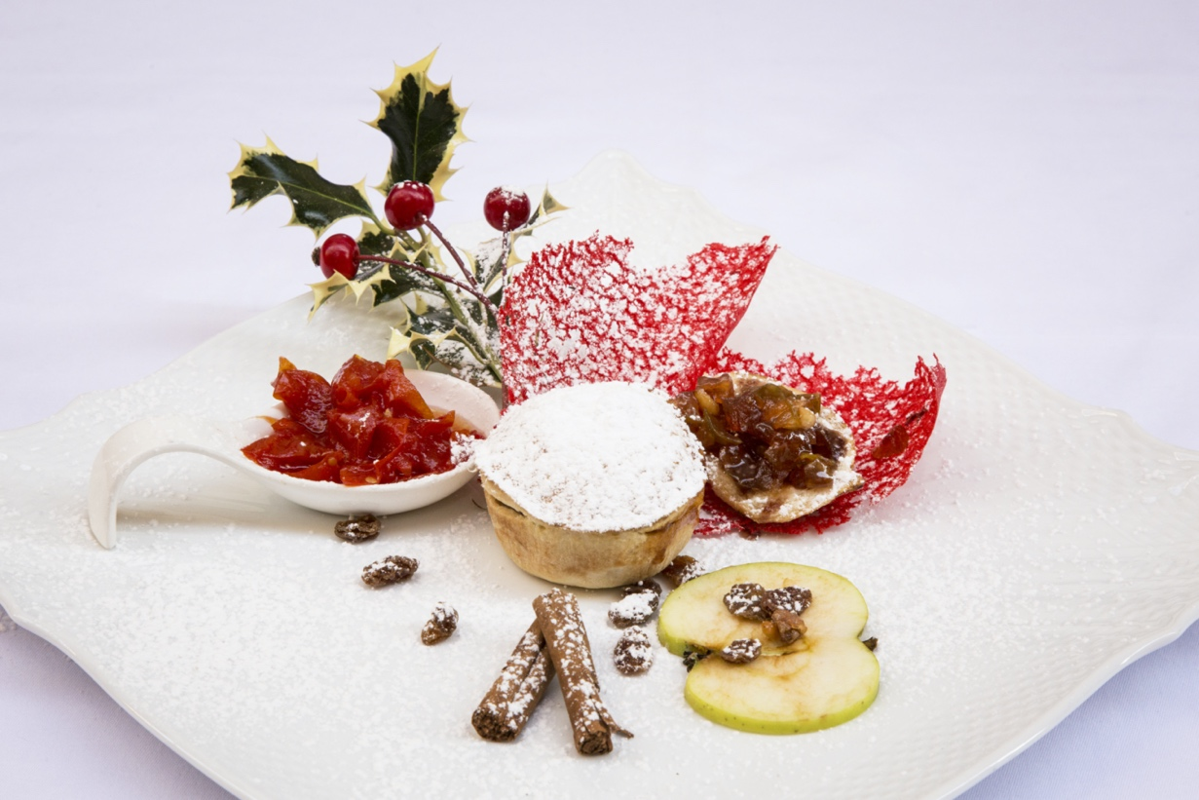
Ingredients:
For the pastry:
510g 00 extra fine pastry flour
255g cold butter
45g icing sugar
7 tablespoons iced water
salt, to taste
For the filling:
680-700 g reinette or fuji apples
1 glass brandy
1 teaspoon cinnamon
1 teaspoon vanilla extract
2 glasses water (400ml)
1 lemon
100g sugar
60g butter
30g raisins
a little milk, to brush the pies
For the jam:
300g canned drained cherry tomatoes
100g sugar
¾ teaspoon salt

Method:
First cut the cold butter into small pieces and put it in a food mixer with the flour, salt and sugar, and mix for
a minute. Add the iced water and mix just for a few seconds to get a rough dough, turn it onto a work
surface and knead by hand until it is smooth and well mixed, wrap in cling film and leave to rest in the
refrigerator.
Wash and peel the apples, cut them into small pieces and place in a bowl with water and squeezed lemon
juice.
Heat the sugar, cinnamon and vanilla in a non-stick saucepan. Add the water and brandy and let the caramel
cook, stirring with a wooden spoon, until it forms large bubbles.

Then add the butter to the caramel and let it melt, add the apples and raisins, sauté the mixture for a few minutes until the apples have softened a little, take off the heat and let the mixture cool.
Drain the canned cherry tomatoes, put them in a saucepan with the sugar and salt and simmer gently for
about 10 minutes, stirring occasionally with a wooden spoon. Then pour the jam into a jar and let it cool.
Lightly grease four 20 cm fluted tart tins with butter. Take the pastry from the refrigerator and on a
floured work surface divide it into 8 small pieces. Roll each pastry piece out with a rolling pin to a thickness
of about 5mm. Line the tins with four of the eight pieces, and put the apple mixture into the center of each,
forming a little mound, dividing the mixture equally. Cover with the remaining four pieces and press down
the edges, cutting off any excess pastry. Crimp the pie crust of each pie using your index finger to push down
on the edge of the pastry and the finger and thumb of your other hand to pinch the pastry either side. With
a sharp knife, make a few slits in each pie near the center. Brush the pies with a little milk and cook in a
conventional oven at 160°C for 35 minutes. Once the apple pies are golden, turn the oven off and
leave them to cool in the oven.
Take the cool pies out of the oven and lay them on individual dessert dishes, with the tomato jam garnishing each portion.

For other delicious tomato-y recipes or for any other tomato-related information please visit our official website or download our app.
Website
https://redgoldfromeurope.jp/ja/

Apple app store
https://rebrand.ly/GTFE-AppStore

Google play store
https://rebrand.ly/GTFE-PlayStore

Follow us on:

Facebook @RGFESK
https://www.facebook.com/red.goldjp.7

Instagram @redgoldjp
https://www.instagram.com/redgoldjp/

Twitter @RedGoldJapan1
https://twitter.com/RedGoldJapan1

Enjoy! It’s from Europe!
Merry Christmas and a very happy and prosperous 2021!
The Red Gold from Europe Team
k.miyaguchi@redgoldfromeurope.com

